Assignment 13
V . Harika
Batch -30
TASK 1: Refactoring – Removing Code Duplication
Code & Output:
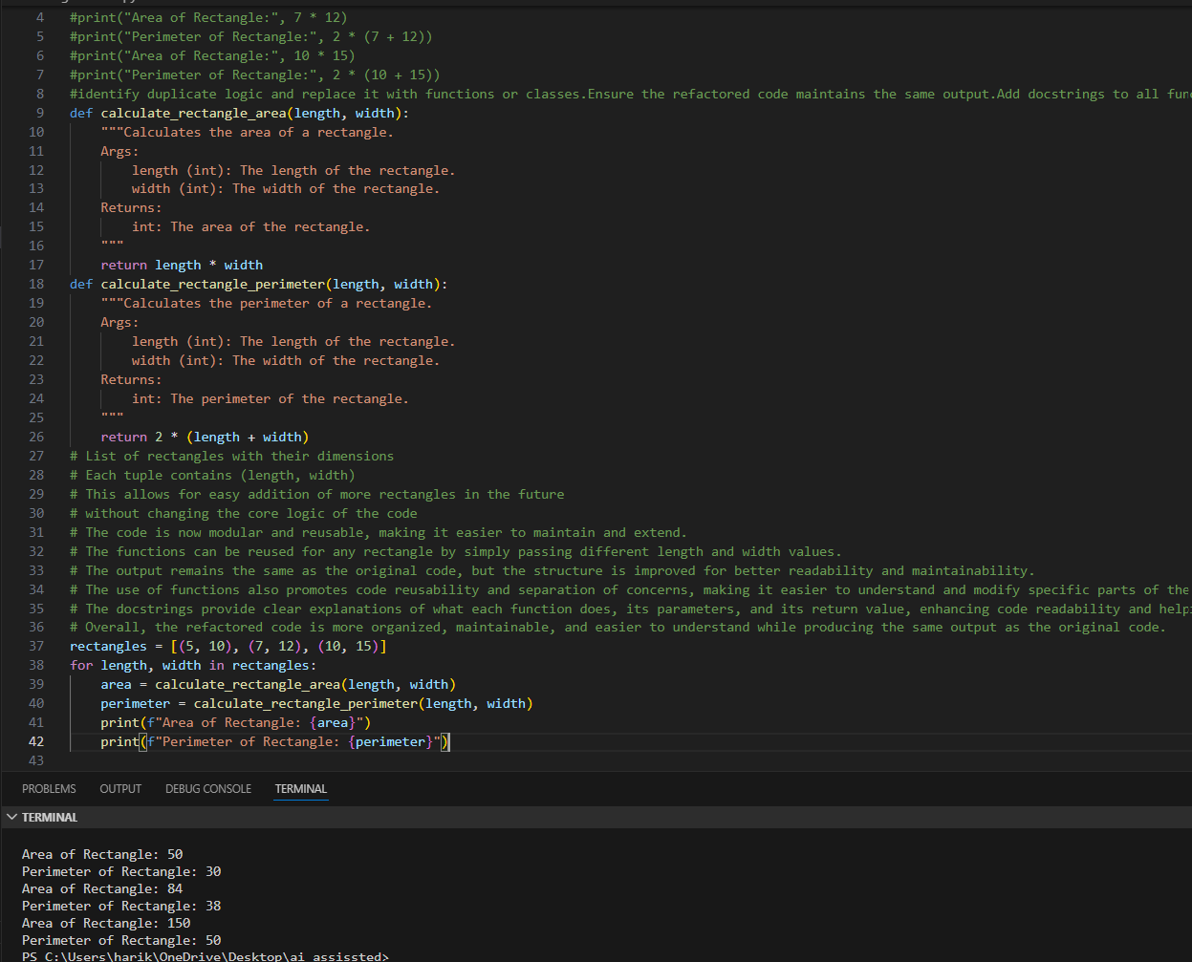
TASK 2: Refactoring – Extracting Reusable Functions
Code & Output:
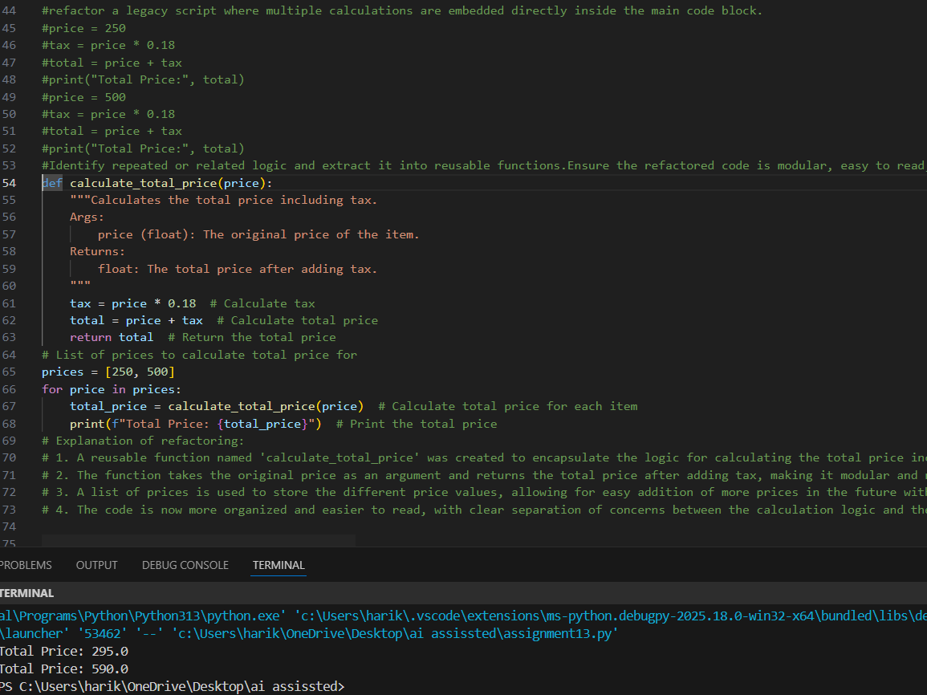
TASK 3: Refactoring Using Classes and Methods
Code & Output:
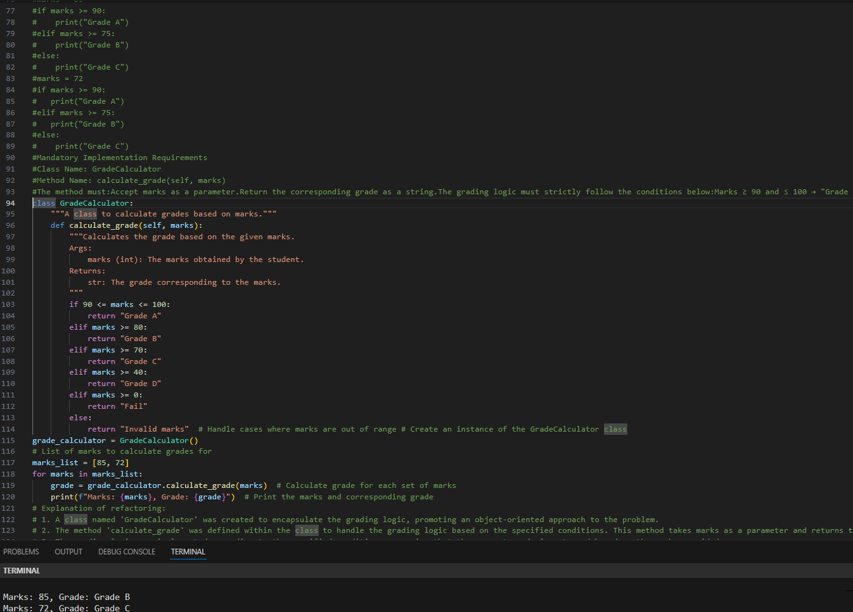
TASK 4: Refactoring – Converting Procedural Code to Functions
Code & Output: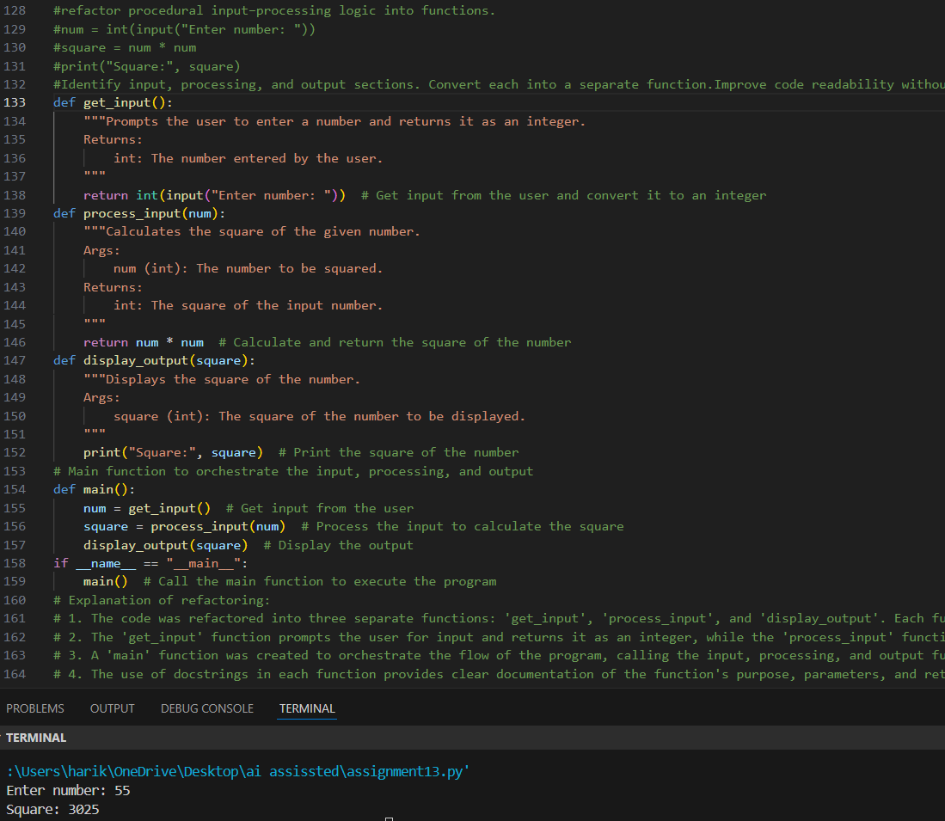
TASK 5: Refactoring Procedural Code into OOP Design
Code & Output: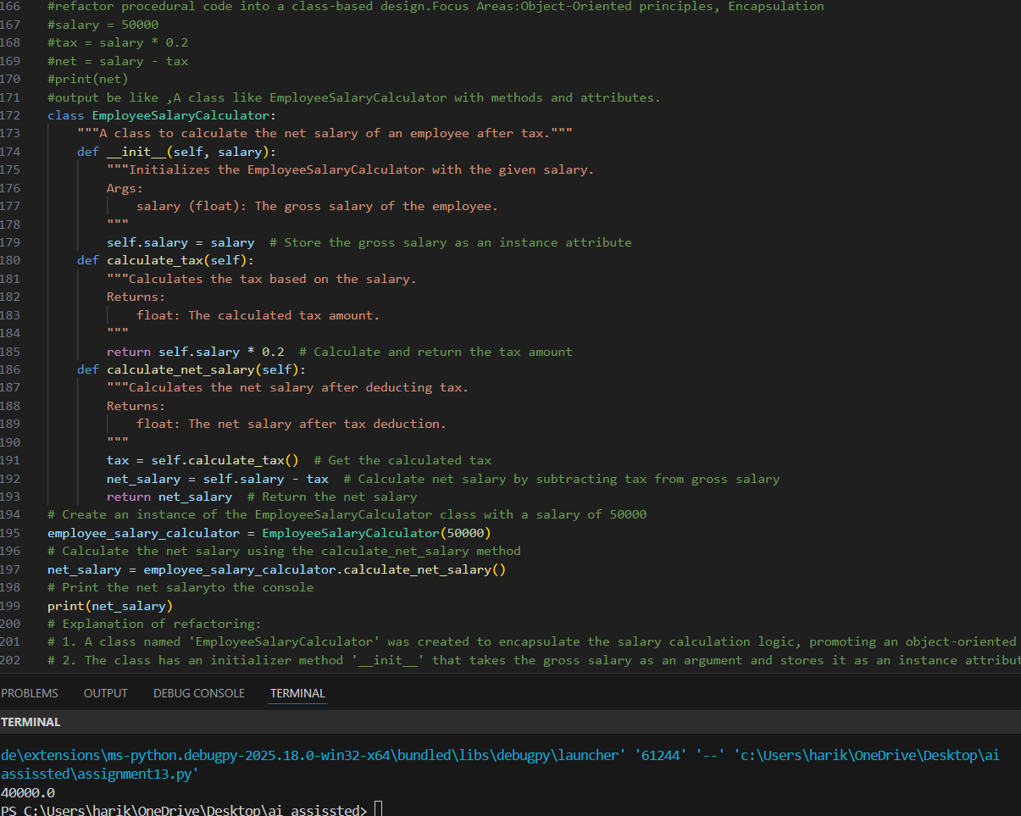
TASK 6: Refactor inefficient linear searches using appropriate data structures.
Code & Output:
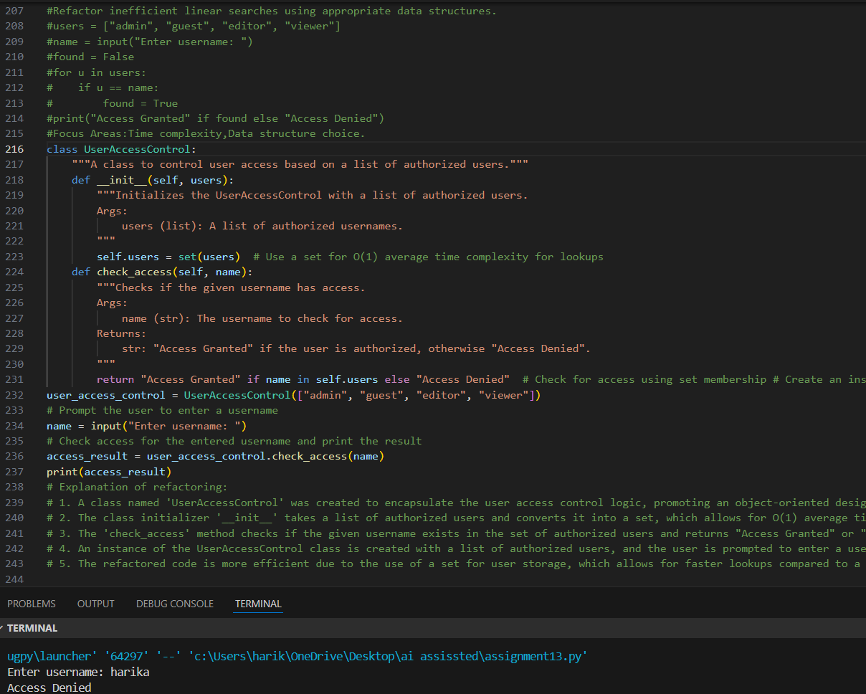
TASK 7: Refactoring the Library Management System
Code & Output:
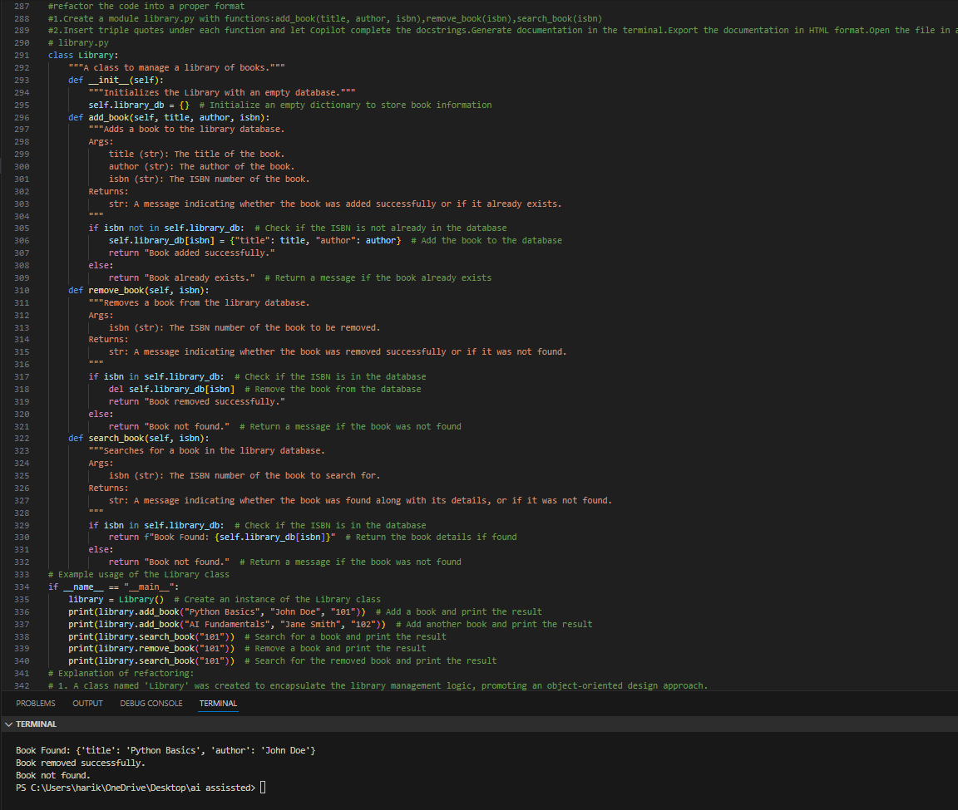
TASK 8: Fibonacci Generator
Code & Output:
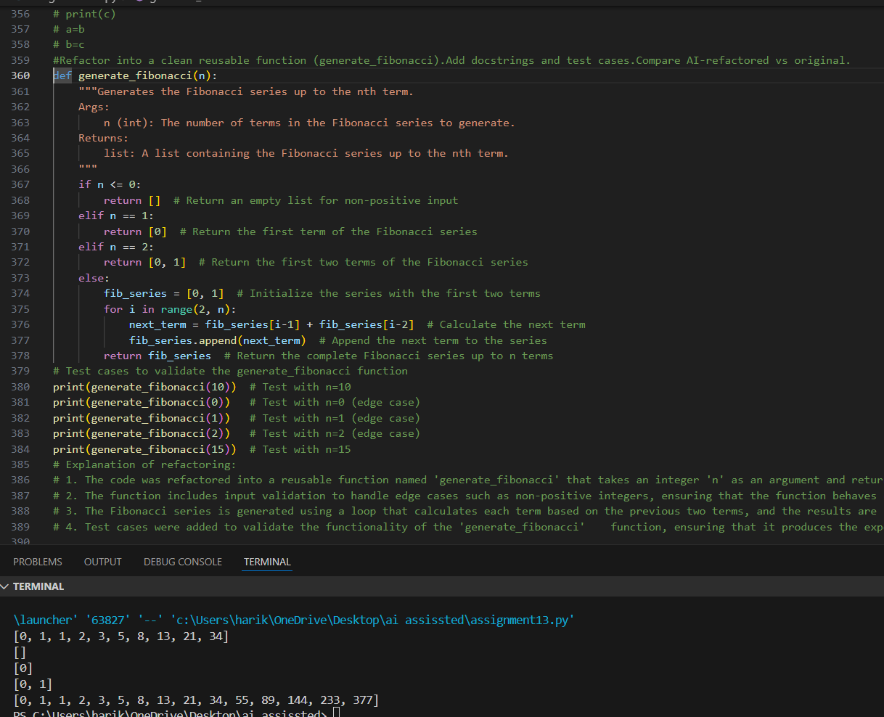
TASK 9: Twin Primes Checker
Code & Output:
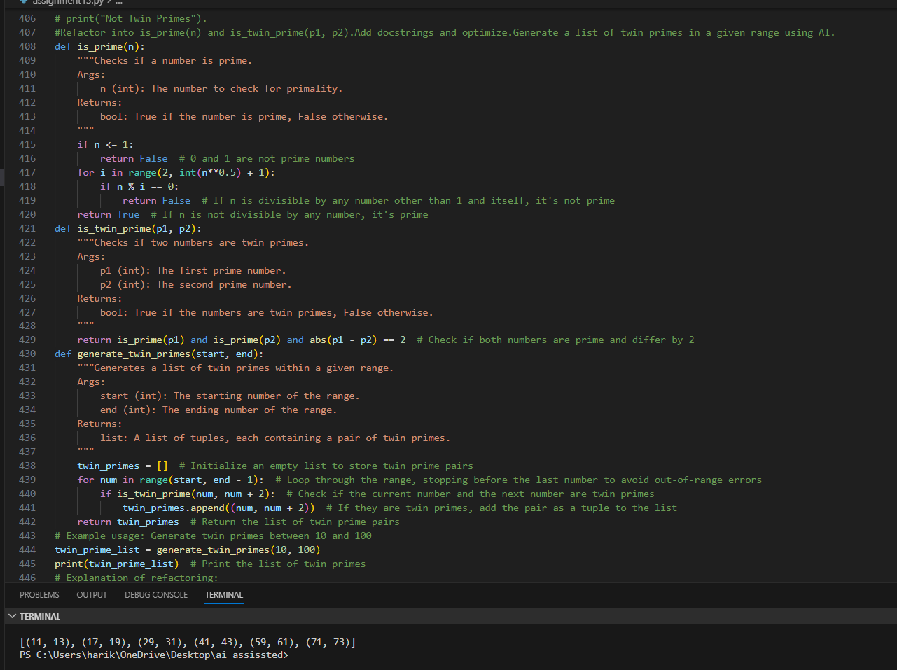
TASK 10: Refactoring the Chinese Zodiac Program
Objective
Code & Output:
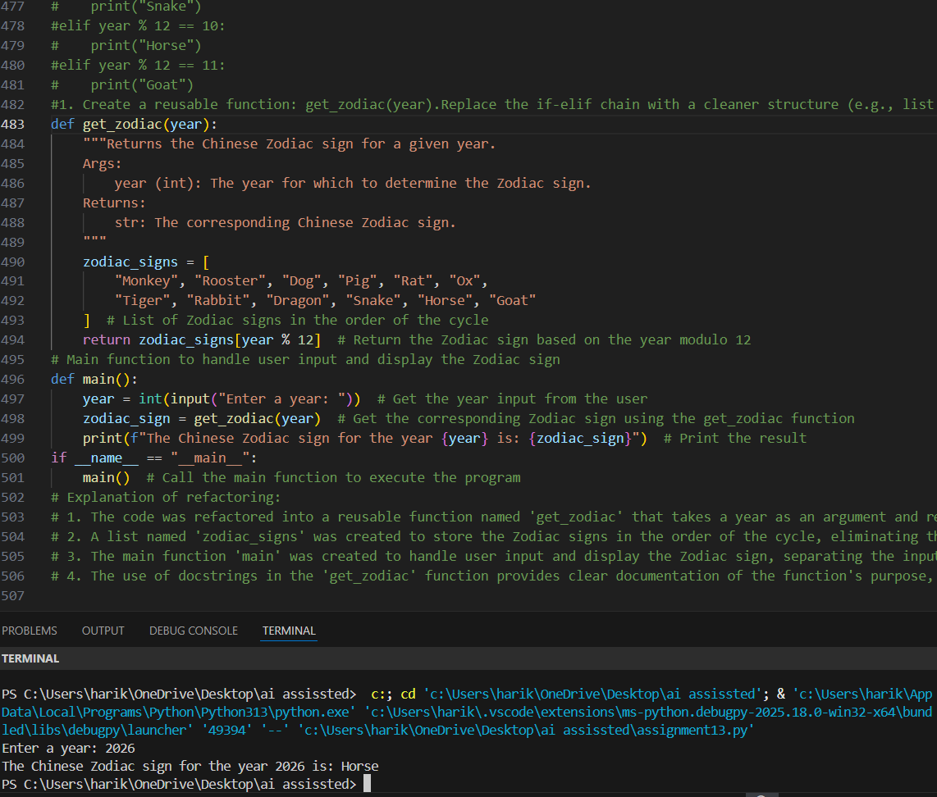
TASk 11: Refactoring the Harshad (Niven) Number Checker
Code & Output:
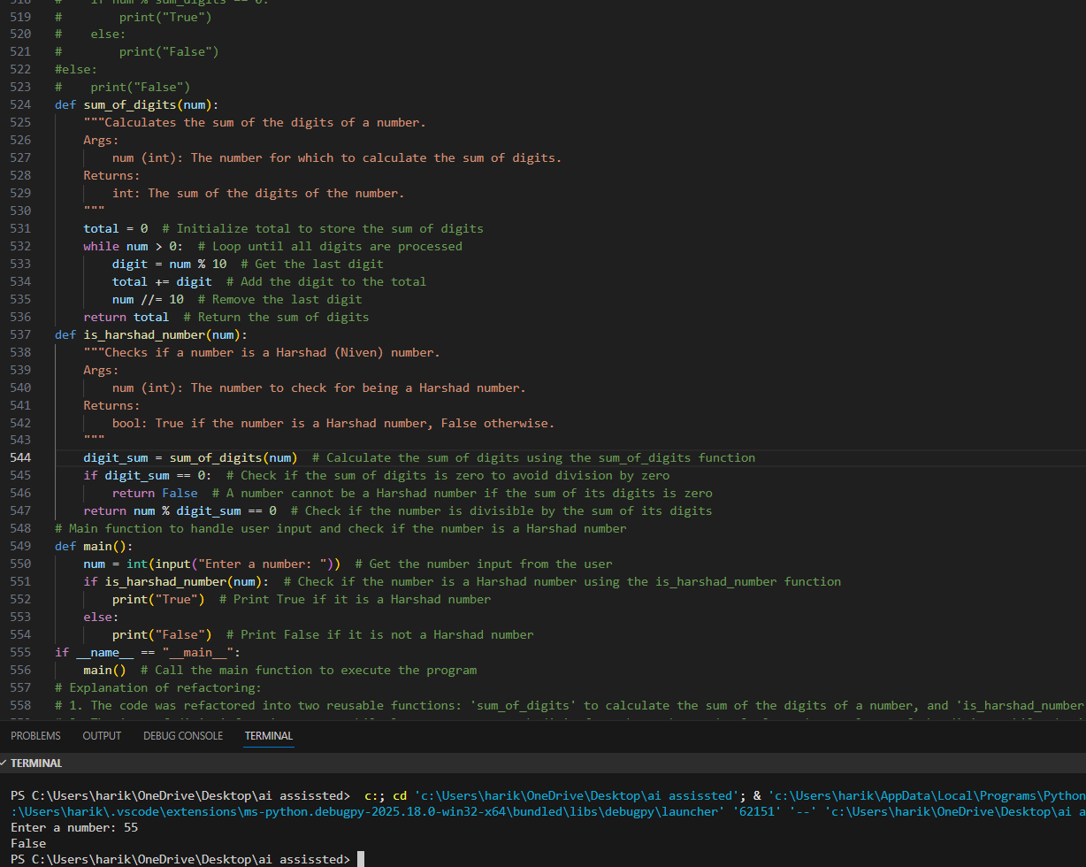
TASK 12: Refactoring the Factorial Trailing Zeros Program
Code & Output:
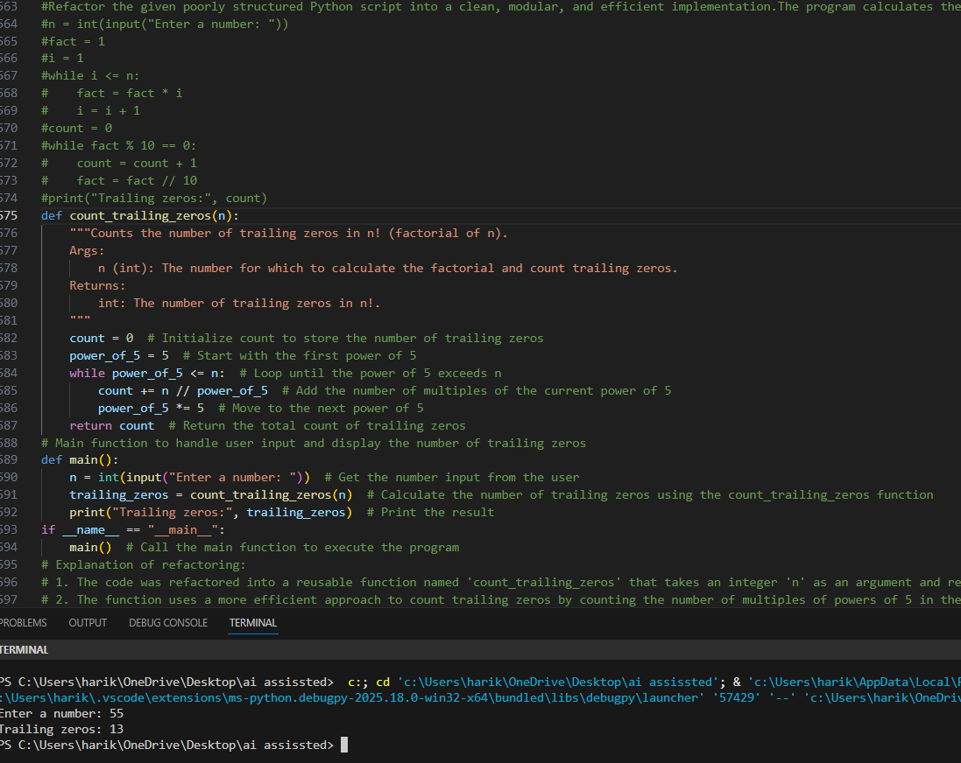
TASK 13: Collatz Sequence Generator – Test Case Design
Code & Output:
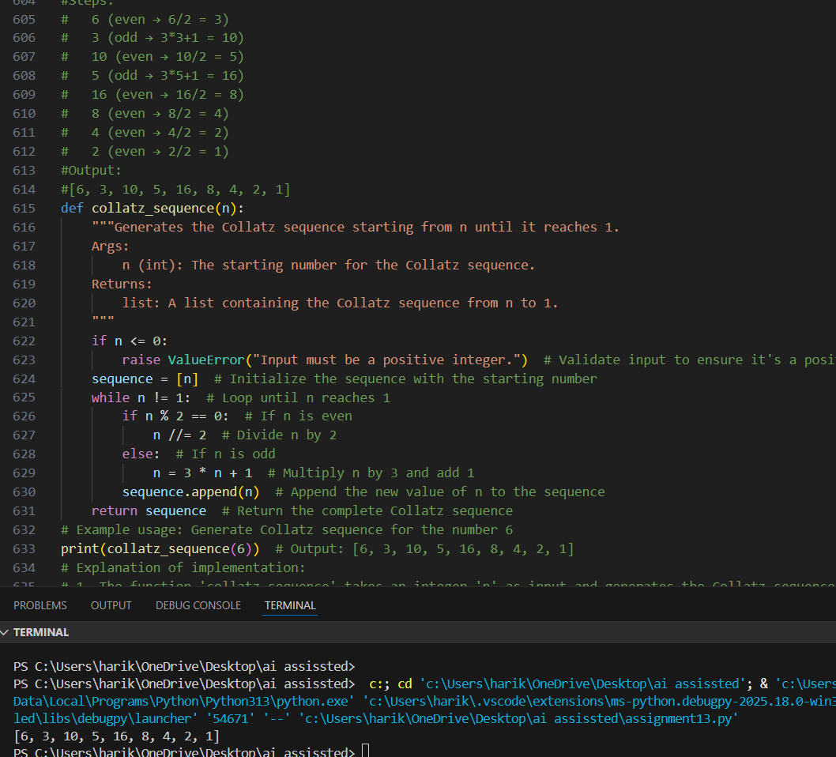
TASK 14: Lucas Number Sequence – Test Case Design
Code & Output:
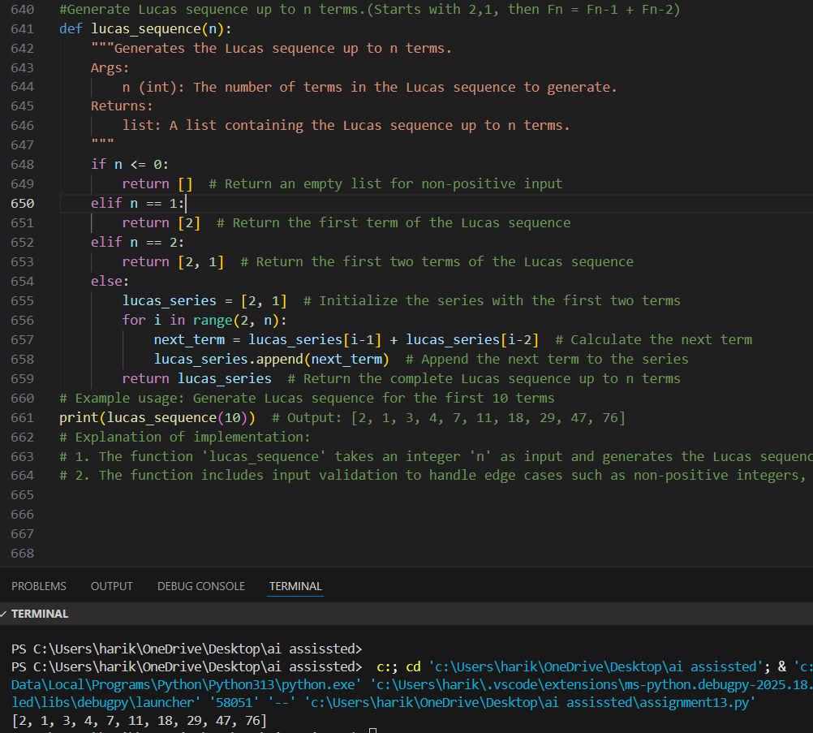
TASK 15: Count vowels and consonants in string.
Code & Output:
